Key

It’s in the Cards

Data and Observations
6 Cards: Observations will vary.

12 Cards: Observations will vary.

18 Cards: Observations will vary.

Analysis
Student Periodic Table Analogy Worksheet
Answers given are based upon the student arranging the cards in four columns and five rows. The columns’ colors are consistent. The student can arrange the cards in five columns and four rows and still reveal all of the patterns. Essentially, this would be like creating a periodic table that has been rotated on its side.

1. How are the first 6 cards similar? How are the cards different?
Answers should include colors, symbols, shapes, and diagonals for both similar and different attributes. Numbers, size of boxes, and amount of sphere that is filled in should be included with differences.

2. Do the additional 6 cards fit into your original arrangement? What patterns did you use to arrange the 12 cards?
Most students will find they need to change their original arrangement to accommodate the six new cards. Patterns will include colors, diagonals, symbols, shapes, and numbers.

3. Describe the classification of your final arrangement for the 18 cards in the following manner.
a) How are the cards arranged in each row?
Students should include sphere progressively filling up, quadrant in center box in same position, and center box size decreasing.

b) What patterns do the cards in a column have in common?
Colors are the same, sphere is at a consistent level, box size increases as you travel down the column.

c) What exceptions to the pattern, if any, are found in your arrangement?
Student answers will vary.

d) List four rules that you used for the classification of your final arrangement.
Colors are consistent in columns
The spheres fill from left to right along the rows.
The diagonal patterns are consistent (triangles, circles, stars, and x’s)
Box size decreases along the rows and increases down the columns (answers will be just the opposite if students pattern is rotated)

4. Predict the patterns (shapes, number, color, etc.,) of the missing cards. Sketch your prediction for the two missing cards in the space provided.

Withholding the same two cards for the entire class makes for a quick assessment. We suggest removing the following two cards.

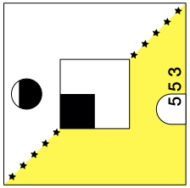
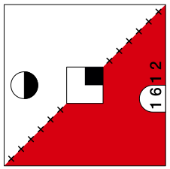

Conclusion Questions
Answers given are based upon the student arranging the cards in four columns and five rows. The columns’ colors are consistent. The student can arrange the cards in five columns and four rows and still reveal all of the patterns. Essentially, this would be like creating a periodic table that has been rotated on its side.

- List one pattern of the cards in the final arrangement that shows a repeating or periodic pattern for each column?
The colors are the same. The level of the sphere remains constant. The box size increases. The number decreases.

- List one pattern of the cards in the final arrangement that shows a repeating or periodic pattern for each row?
The quadrant in the center box stays in the same position. The sphere fills up from left to right. Box size decreases.

- Elements in each column of the periodic table are known as a group or family and rows are called periods. Would these names also be appropriate for your arrangement of cards? Explain.
Yes these names are appropriate. It is appropriate because they share similarities like families do, whereas, the periods show repeating patterns or trends.

- The atomic radius of an element is approximately the distance between the nucleus of the atom and the outermost electron cloud. If a square on the card represents the atomic radius, then describe what happens to the atomic radius when you move from left to right along the rows and down the columns.
Atomic radius decreases as you move from left to right and increases as you go from top to bottom.

- Place your finger on the thumbnail sketch at the bottom of each card and write down the numbers that you see. Do the numbers increase or decrease as you move left to right along the rows? Do the numbers increase or decrease as you move down the columns?
The numbers increase as you move from left to right and increase as you move down the columns.

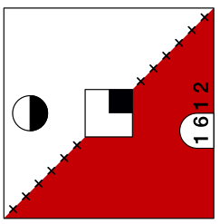
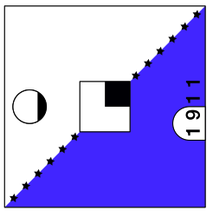
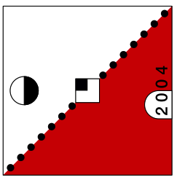
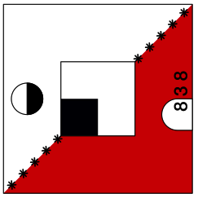
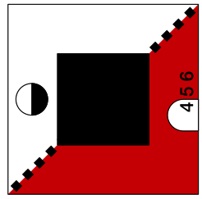
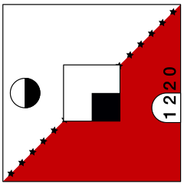
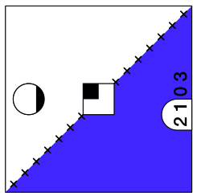
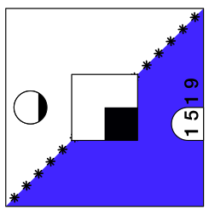
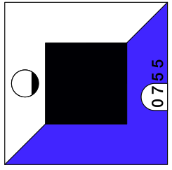
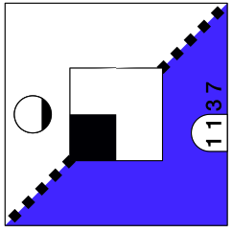
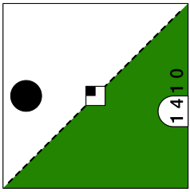
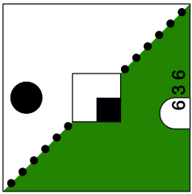
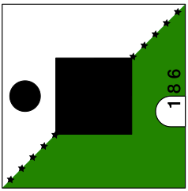
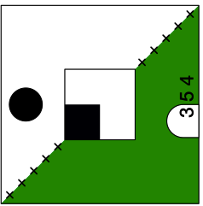
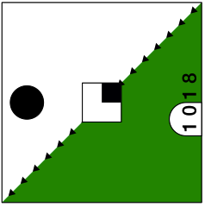
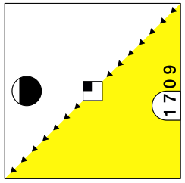
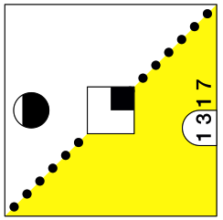
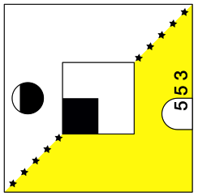
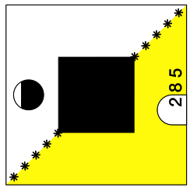
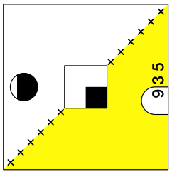
Atomic # when covered
Patterns consistent diagonally
Color consistent
- Box size increases down the column + (Atomic radius)
Shading in box consistent
+ Box size decreases - (Atomic radius)
Spheres filling with valence electrons

