Science Zone – Lesson Plans: Sound (Musical Instruments)
To be presented at Wilson Elementary School Thursday, April 27, 2008

Overall Objectives:
- The students will form a conceptual understanding of the terms “sound waves”, “frequency”, “resonance”, “compressed waves”, “transverse waves” and “pitch”
- The students will form a conceptual understanding of how sound is created on a musical instrument

Average length of SeeS Session: 45 minutes

Supplies needed:
Materials to make all four instruments (listed later with the instructions on how to make the instrument).

NOTE: Have the main parts that require using the sharp or hard to use tools already finished before the Science Zone session. The students will finish putting the pieces already created together. It is also good to have one already made so the instructor and the students will understand how the final product should look.

Vocabulary:
- Sound waves-The longitudinal progressive vibrations in elastic medium by which sounds are transmitted.
- Frequency - the number of occurrences within a given time period
- Resonance – This is the vibration frequency of a rotating or moving object.
- Compressed (longitudinal) Waves – A wave propagated by means of compression and the vibrations are in the same direction as the plane of motion
- Transverse Waves – Vibrations are at right angles to the direction of the wave.
- Pitch – the property of sound that varies with variation in the frequency of vibration

Associated or informational files for this SeeS Session and LP (Word, PDF, Excel, Flash Videos):
- 2008_SZ_Station.ppt
- 2008_LP_SZ_Sound
- Supplemental

Science Zone Session Outline:
- Introduction 2-3 minutes
  - Instructor will talk about Sound and different types of instruments

- Stations 40 minutes
  - Have students break into 4 different groups (each group will make a different instrument)
  - After they make their instrument, they will present their instrument to the rest of the students.

- Wrap up 2-3 minutes
  - Wrap up with asking what one thing was in common in making all the instruments make sounds… answer: some type of vibration.
  - Ask if they have questions.

Instructions on how to make the Bleach Bottle Banjo

Materials:
- 2 to 4 qt size plastic container
- 30 in x I in x 2 in wood strip for the neck
- 3 yards nylon fishing line (40 to 60 lb test)
- 3/4 in x 2 in x 1/4 in piece of wood for bridge
- 2 screw eyes or other tuner options
- 2-1 in finishing nails for hitch pins
- Saw
- Hammer
- Safety scissors
- Sandpaper
- Supplemental file: SZ-bleach_bottle_banjo.pdf

Directions:
- Cut off bottom half of plastic container. On opposite sides of container, cut trap door flaps close to the resonator playing surface so that the fingerboard fits snugly when the flaps of the container are folded out and the wood strip is inserted (see photo 1).
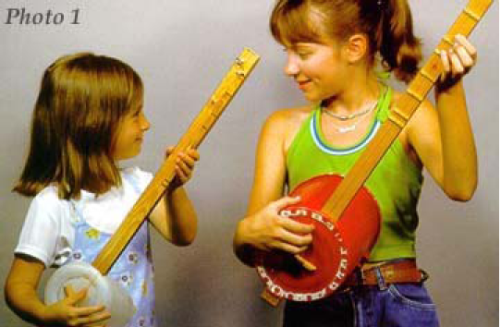

- At the tail of the instrument, hammer in hitch pins side by side so that only a small portion of the nail protrudes. (see Photo 2) At the head of the instrument, place screw eyes so when turned they do not bump into each other. Do not screw them in too far until after strings are attached.
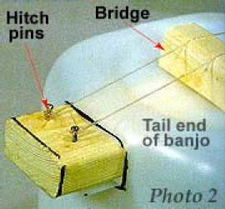

Continue for Bleach Bottle Banjo

- Secure fishing line strings between nails and screws. Tie knots so they will not slip when tensioning strings.
- Insert small chunk of wood under strings for bridge. Cut shallow slots into bridge to keep strings from sliding off.
- Add a small piece of wood next to the screw eyes (tuning pegs) for nut (see Photo 3). Also see Making Frets.
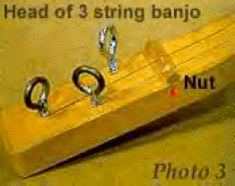
- Tension strings by turning screw eyes into wood. Make adjustments where necessary. Strings should be fairly tight for maximum resonance.
- Paint or decorate resonator, if desired.

Making Frets
- Add a small piece of wood (a nut) next to the tuning pegs to delineate a more precise string length between nut and bridge. Notes of a major scale can be marked on the fingerboard or make simple frets using 3/4 inch dowels flattened on one side and glued along the fingerboard at the appropriate places. The nut should be notched and should raise the strings just enough above the fingerboard to pass slightly above the first fret. If the strings bump into frets farther along the fingerboard while fingering the first three or four frets, raise the height of the bridge slightly to correct this.

To Play
- Tune the strings to create whatever pitch relationship you wish. I suggest unison tuning: one string acts as a drone, the other as a melody string. After tuning, hold and strum the instrument in guitar-like fashion. By stopping the melody string along the board neck with your fingers, you can pick out scales and melodies. Making fret marks with a felt pen at appropriate places along the fingerboard will help you find the scale notes. I prefer a regular do-re-mi diatonic (rather than chromatic) scale for playing simple melodies.

These directions are from http://www.waringmusic.com/bleach_bottle_banjo.htm

Instructions on how to make the Glockenspiel

Materials:
- ½ “ Metal pipes
- Metal pipe cutter to cut the metal to certain lengths
- String
- Supplemental file: SZ-glock.pdf

Directions:
- With a metal pipe cutter (not a hacksaw), cut the tubing into the five sections listed below (some full-service hardware stores will do this for you).

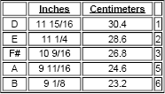

- Arrange your tubes as shown so that the longest is on the bottom and the shortest is on top.
- String the tubes together (simple knots will do) along both sides so there are 2 inches between each tube. You may also place the tubes on two pieces of felt or foam rubber.
- Try different "mallets" (metal/wood/plastic) to obtain a variety of timbres.

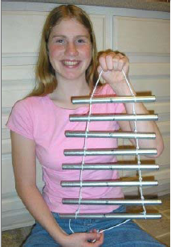

These directions are from http://www.philtulga.com/glock.html

Instructions on how to make the Pan Pipes

Materials:
- 2 feet of 1/2-inch/schedule-40 PVC sprinkler pipe.
- Tool to cut the pipe to given lengths
- 6 pennies
- Sturdy tape (duct tape)
- Wooden stick or tongue depressor (optional but helpful)
- Supplemental file: SZ-panpipes.pdf

Directions:
- Cut the tubing into the five sections listed below.

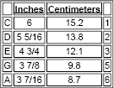

- Place a penny over one end of each pipe and cover each penny with a 2" X 2" square piece of duct tape.
- Wrap about 18 inches of duct tape around the set as shown on the right. Use the wooden stick or tongue depressor to help keep the pipes together.
- Blow across the top of each pipe — it's just like blowing on a soda bottle.

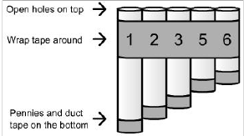

These directions are from http://www.philtulga.com/Panpipes.html

Instructions on how to make the Thumb Piano

Materials:
- 1x4s or 2x4s cut into 4" or 5" lengths
- colored masking tape
- push pins
- large bobby pins (straightened and cut to differentlengths)
- craft sticks
- rubber band

Directions:
- Glue two crafts sticks onto board securing with a rubber band (diag.A).

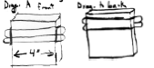

- While the glue is drying decorate the board with colored masking tape.

- Tape four bobby pins of different lengths onto the crafts sticks (diag.B).

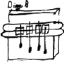

- Glue two more crafts sticks on top of the taped bobby pins and secure with rubber band (diag.C).

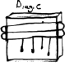

- Push colored push pins through both sets of crafts sticks and into the board to hold the bobby pins tight so they will make a good sound (diag.D)

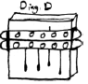

- After the glue has dried, bend each bobby pin up to about a 45 degree angle so you can thumb them with you thumbs.
Note: If you put you thumb piano against other things such as a table or another instrument, the sound will be louder. See what makes the best sound.

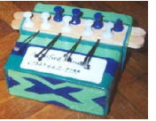

These directions are from http://www.satisfied-mind.com/make/thumb-piano.htm

