Materials:
- ½ “ Metal pipes
- Metal pipe cutter to cut the metal to certain lengths
- String
- Supplemental file: SZ-glock.pdf

Directions:
- With a metal pipe cutter (not a hacksaw), cut the tubing into the five sections listed below (some full-service hardware stores will do this for you).

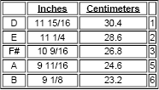

- Arrange your tubes as shown so that the longest is on the bottom and the shortest is on top.
- String the tubes together (simple knots will do) along both sides so there are 2 inches between each tube. You may also place the tubes on two pieces of felt or foam rubber.
- Try different "mallets" (metal/wood/plastic) to obtain a variety of timbres.

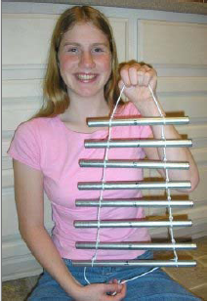

These directions are from http://www.philtulga.com/glock.html

