Wilson Cloud Chamber
Demonstration

written by:

Tom Farrar
Jim Gray
Richard Yoesting

Wilson Cloud Chamber Demo

I. Introduction
II. Apparatus
III. Demo As Intended
A. Procedure
1. Preparation and assembly
a. Alcohol-water mixture
b. Radiation source
c. Cloud chamber
i. Dust free cloud chamber interior
ii. Cloud chamber
iii. Test for leaks
2. Performing the demo/experiment
a. The demo/experiment
b. Other considerations
B. Results/ statistical analysis
C. Conclusions

IV. Modified demo
A. New parts
1. Caps
2. Thin film
3. Magnetic field
B. Procedure
1. Alpha source
2. Beta source
C. Conclusions

V. Final conclusions/suggestions

Appendix A. -- Reference materials
Appendix B. -- Diagrams/specs for caps
Appendix C. -- Mathematica notebooks
Appendix D. -- Complete Raw Data and Statistics

I. Introduction

C.T.R. Wilson originally developed the cloud chamber between 1896 and 1912. This was an exciting development in the history of physics since the cloud chamber allows us to observe, albeit indirectly, individual submicroscopic charged particles in the form of energetic radiation. Cloud chambers use a supersaturated vapor solution that condenses around ions produced by the passage of  or  particles through the solution. This supersaturated vapor solution, or cloud, is produced in much the same way as weather clouds are formed, by the adiabatic expansion of a vapor solution. The visible cloud is the excess liquid that cannot be held in solution. The radioactive particles then ionize the gas and the resulting ions serve as “nuclei” for the liquid to condense around, leaving a visible trail indicating the path of the particles.

II. Apparatus
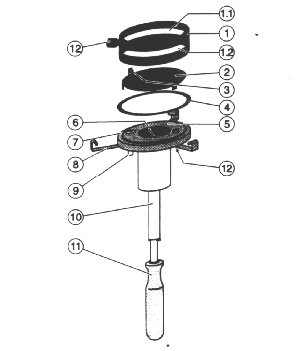

Apparatus parts list

(1) Chamber cover
(1.1) Observation window
(1.2) Illumination window
(2) Base plate
(3) Holder for charged particle source
(4) Rubber ring gasket
(5) Absorbent felt pad (on underside of 2)
(6) Evacuation opening
(7) Chamber base with built-in vacuum pump
(8) Clamps for attaching (1) to (7)
(9) Vent valve
(10) Pump piston guide tube
(11) Handle of piston pump
(12) 4 mm sockets for applying DC voltage

Additional required equipment:
DC power supply (~ 450 V)
Bench clamp (to mount apparatus to bench)
Light source (and attendant accessories)
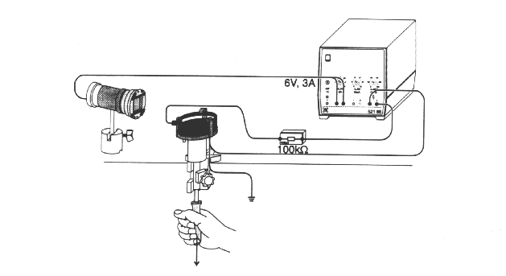
Typical experimental setup

III. Demo as Intended

Objective:
To perform the Wilson Cloud Chamber demo/experiment as intended by the makers of the apparatus. The intent is to produce vapor condensation trails by forming a super-cooled, super-saturated alcohol-water vapor by way of adiabatic expansion and introducing alpha particles into the vapor which will produce ions about which the vapor will condense (change state from vapor to liquid). The effect is short lived (only a few seconds in duration), so we will videotape record the experiment (to obtain statistical data).

A. Procedure

1. Preparation and assembly

a. Alcohol-Water mixture
Three different alcohol types were used to perform the experiment: ethyl, isopropyl, and methyl. The alcohol is mixed 1:1 with distilled water ( “arbitrary” choice: 5 ml alcohol and 5 ml water ). The felt pad (located on underside of base plate) is moistened with the entire 10-ml alcohol-water mixture.

b. Radiation source
After choosing a radiation source (in our case, alpha source²²⁶Ra), mount the source on the holder on the topside of the base plate.

c. Cloud chamber

i. Dust free cloud chamber interior
For best results, it is necessary to have the interior of the cloud chamber as dust free as possible (so that vapor condensation will only occur on the ions produced by the radiation source). This can be accomplished by using compressed air to blow dust off of the interior chamber surfaces and, if necessary, distilled water can be used to clean the interior chamber surfaces. Best to do this before mounting the radiation source.

ii. Cloud chamber
Place rubber ring gasket on and mount base plate (after radiation source is mounted on holder and alcohol-water mixture has moistened felt pad) on chamber base. Place chamber cover over rubber ring gasket and engage the three cover clamps. Ensure that venting valve is closed. Connect leads from DC power supply to appropriate sockets (+ on cover, - on under side of chamber base). After testing for leaks, turn on power supply.

iii. Test for leaks
To produce the required super-cooled vapor mixture, we must subject the vapor to an adiabatic expansion. This is accomplished by a rapid pull of the piston pump and holding the piston in the end position. Before attempting to perform the experiment the seal of the cloud chamber must be tested. First rapidly pull the piston down and listen for audible leaks. Re-seating the chamber cover on the rubber ring gasket and chamber base can often seal audible leaks. Other common sources of audible leaks are at the electrical sockets located on the chamber cover and chamber base. Socket leaks can be sealed with O-ring gaskets (grommets) or a small amount of vacuum grease (use only as a last resort). To ensure all leaks have been found one could use either a stethoscope (or a tube) to hear very small leaks or use a liquid leak detector.

2. Performing the demo/experiment

a. The demo/experiment
The experiment is best performed in the dark with the interior chamber illuminated, through the sidewalls, by an external source. Every attempt must be made to ensure that the light source does not heat the chamber as the event inside the chamber is due to adiabatic expansion (no heat into or out of the system, only temperature and pressure can change). A secondary effect of improper lighting is the production of unwanted convection currents. The light source should be UV filtered for these reasons.

A rapid pull of the piston pump will decrease the pressure and temperature of the cloud chamber interior, producing a super-cooled vapor. If the chamber interior is not dust free a cloud will be visible. Distinct condensation trails will form along the path of ionized particles produced by the emitted radiation source particles. The experiment can be repeated every 1 to 1.5 minutes, this time allows for the applied electric field (~150 - 200 V) to de-ionize the chamber and for thermodynamic equilibrium to be re-established.

b. Other considerations
As the condensation trail event is very short lived (only a few seconds), it is best to record the experiment and do statistics later by viewing the video tape. To videotape the events inside the chamber we mounted a camera above the chamber looking straight down. The tip of the radiation source is visible in the camera shot (to provide viewer with orientation of the arrangement). It was discovered that it was best to direct the light source in near opposition to the path of the source particles. This places glare (due to reflection from chamber interior walls) from the light source out of the field of view.

B. Results / Statistical Analysis
In the performance of the experiment, three different 1:1 alcohol-water mixtures were used: ethyl, isopropyl, and methyl. Data were taken from 10 trials of the experiment for each alcohol mixture to determine if any significant statistical differences could be found (see Appendix D and table below).
 | Ethyl (# of trails) | Isopropyl (# of trails) | Methyl (# of trails)
 | 1 | 3 | 4
 | 3 | 2 | 1
 | 3 | 4 | 1
 | 3 | 5 | 2
 | 3 | 1 | 3
 | 2 | 2 | 2
 | 1 | 2 | 4
 | 6 | 5 | 4
 | 3 | 2 | 1
 | 2 | 1 | 5
Mean | 2.7 | 2.7 | 2.7
Standard Deviation | 1.42 | 1.49 | 1.49
Median | 3.0 | 2.0 | 2.5

After ten trials with each mixture, no clear statistical differences are apparent. For each mixture, a total of 27 trails were observed, so each yield the same mean 2.7 trails per pull. Standard deviation differences are minimal and insignificant. Only the median values resemble “significant” differences, but the significance (if any) of the difference is unclear.
From a purely qualitative view, the trails produced in the methyl vapor were “fluffy” and faint when compared to those in the ethyl and isopropyl, which appeared to be more “dense”. The “density” of the ethyl and isopropyl trails makes them easier to distinguish from the cloud.

C. Conclusions
The demo/experiment performed as expected, with best results obtained when waiting the full 1 to 1.5 minutes between trials. Perhaps more statistical data should be collected to determine if there are, in fact, significant differences in the number of trails produced in the different alcohol-water mixtures (due to variances in vapor pressures). If such differences could be determined, the mixture could be chosen such that the likely number of events (condensation trails) that occur in a given trial could be “tailored” to suit a modification/extension of the demo/experiment (such as deflecting the particle path by a magnetic field).

IV. Modified Demo

Objective:
To extend the Wilson cloud chamber demo by deflecting the particle path with a magnetic field. To facilitate such an event, new parts were machined (to collimate the particle path and/or mount thin film to reduce particle energy). Also the possibility of using a different source was explored. Again, a principal goal is to video record the event.

A. New equipment
To deflect the path of the alpha particle it was determined necessary to reduce the particle’s net momentum. To accomplish this task calculations were made to determine the stopping power of thin films (to reduce particle energy) and magnetic field strengths required to cause observable deflection within the confines of the chamber (see Appendix C).

1. Caps

Alpha source
Caps which fit snug over the ²²⁶Ra housing were machined from aluminum, since it is non-magnetic, easy to machine, and readily available. Two types of caps were designed and built (see Appendix B). Type 1 has an aperture diameter slightly larger than of the ²²⁶Ra housing and a 0.05-inch long “tunnel” aperture through which the particles must pass. This cap has the dual purpose of collimating the particle path and allows for the mounting of a thin film to reduce the particle energy. Type 2 has an aperture diameter which is ~1/2 that of the source housing and an aperture “tunnel” of 0.15 inches to ensure a collimated path. Three Type 1 caps and one Type 2 cap were produced.

Beta source
Caps to fit over a toothpick “doped” with ³²P were machined to collimate the particle path. These caps were machined from brass, since it is non-magnetic, relatively easy to machine, readily available, and is of sufficient stopping power to collimate beta particles. The “cap” is essentially a cylinder, with outside diameter such that a Type 1 or 2 cap can fit it, with a hole drilled through the center lengthwise. One “cap” of this type was machined (see Appendix B, Type 3 Cap).

- Thin film
The radius of the loop formed by the charged particles is given by $r=\frac{\text{mv}}{\text{qB}}$, so the radius of the loop is directly proportional to the velocity of the particles. Therefore, if we wanted to deflect the particles, we needed to slow them down. We decided to place a thin film of material in front of the sample. In theory, the particles would lose energy as they passed through the film, and we would then be able to better affect their trajectories with the magnet. Obviously, different materials at different thickness attenuate radiation at different rates, so we considered several different kinds of thin films. We decided to use the most readily available to us – Saran Wrap.

3. Magnetic Field
In order to deflect the particle path, we relied on the Lorentz force, $F=q(E+v´B)$, where v is the velocity of the particle and B is the magnetic field strength. Any charged particle moving through a magnetic field should experience this force, normal to both the direction of motion and the magnetic field. In addition, as the radius of curvature of a deflected charged particle is inversely proportional to the magnetic field, as large a B field as possible is required. So, in order to generate the magnetic field, we used a small rare earth magnet. Unfortunately, we did not know the strength of the magnet, and we had no way of determining this value short of an extensive, additional experiment.

B. Procedure
Repeat procedure as in Section IV-A, but include the following modifications:

- Alpha source
The first modification we made to the procedure was to introduce a magnetic field. Any charged particle moving through a magnetic field will experience the force $F=q(E+v´B)$. As a result, the particle will move in a circular path whose radius is given by $r=\frac{\text{mv}}{\text{qB}}$. We placed a small rare earth magnet (ideally, the magnet would be large enough such that the magnetic field would be effective over the entire path length) inside of the chamber, beneath the path of the particle, arranged such that the magnetic field lines were perpendicular to the path, and used the same  source as before, ²²⁶Ra. When we sealed the chamber and, supercooled the vapor, we observed no deflection in the  particle trajectories. Because the radius of the loop is directly proportional to both the velocity and mass of the particle, and inversely proportional to B, we concluded that the  particles were moving too quickly, and/or were too massive, and/or the magnetic field strength was too weak to be noticeably deflected by the magnet.
The first issue, reducing particle velocity, was deemed easiest to address. In order to slow the  particles, we decided to place a thin film, mounted on a Type 1 cap, in front of the  source, because the particles should lose energy as they traverse the film. To choose the thin film, we needed an idea of what kind of material we should use and how thick it should be (see Appendix C). To find the range of energetic particles in various materials, we used the formula $R»R_{\text{air}}1\text{.}\text{512}´{\text{10}}^{−4}\frac{A}{ρ}\frac{\sqrt{\text{10}+Z}}{Z}$ where R_{air} is the range in air, A is the atomic weight,  is the density in g/cm³, and Z is the atomic number. We then reasoned that the rate of energy loss for a specific material would be the initial energy over the range in that material. A plot of the energy remaining versus the thickness of material is shown for several materials in Figure 1. We attached a thin film of Saran Wrap (~ 12.5 μm thick) to one of the Type 1 caps we manufactured, and we mounted the cap onto the ²²⁶Ra source housing. However, when we supercooled the vapor, we observed an almost complete absence of ion trails.

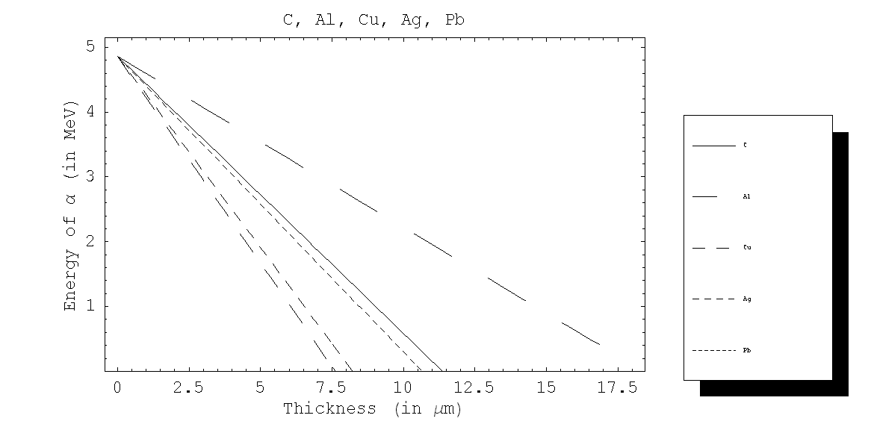
Figure 1

2. Beta source
Because we were not able to visibly deflect the  particles, we decided to use a different source (this addresses issue #2, the particle being too massive). We chose ³²P, a  source that emits particles at an energy of 1.7MeV, because it was readily available. A Type 3 cap was placed over the source to collimate the path of the emitted particles. Because the radius of the loop is directly proportional to the mass of the particle, it is much easier to deflect  particles with a given magnetic field. A plot of the radius of the path of  particles versus the magnetic field strength is shown in Figure 2. We put the rare earth magnet and the  source into the chamber, but followed the original procedure otherwise. When we supercooled the vapor, we did not observe any ion trails whatsoever.
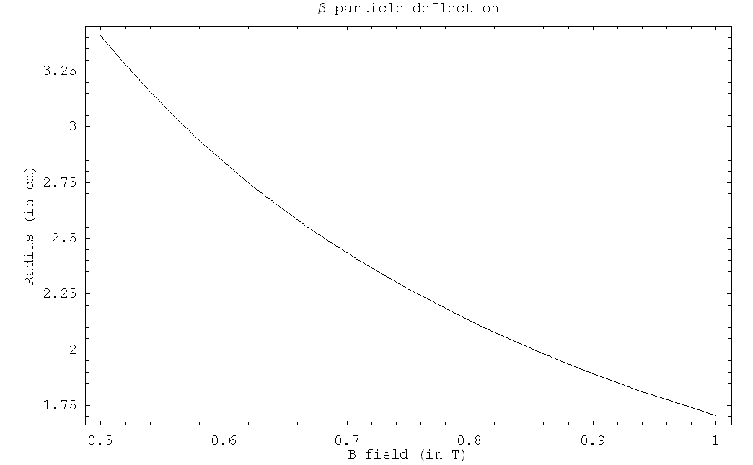
Figure 2

C. Conclusions
When we used the ²²⁶Ra source, we tried to deflect the  particles with a magnetic field. At first, we did not observe any deflection, so we inserted a thin film of Saran Wrap in front of the source in order to slow the  particles. A plot of the radius of the loop versus the thickness of the film and the magnetic field is shown in Figure 3. After we placed the film in front of the source, the number of visible trails was very low, and the very few trails that were visible were too short to observe any deflection. Our hypothesis was that the alcohol-water vapor was condensing on the film, preventing the vast majority of the  particles from penetrating the film.

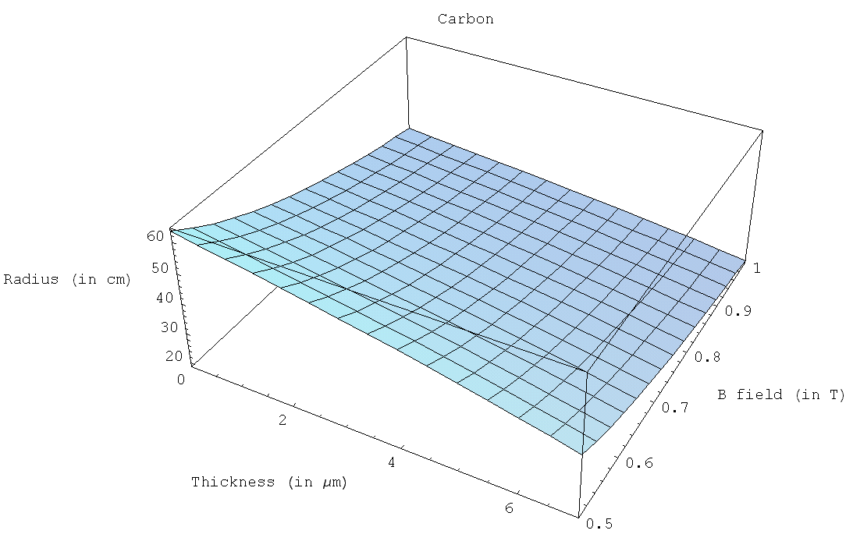
Figure 3
After we switched to the ³²P source, we did not observe any trails at all, even without a thin film. We believed that the  particles were simply not able to ionize enough gas molecules to form a visible trail. First, the  particles had a momentum ~118 times smaller than that of the  particles. Also, the relative cross section of the  particles was much smaller than that of the  particles. If we had observed trails, we could have placed films in front of the source, slowing the  particles. Of course, different materials attenuate radiation at different rates. The actual rate at which  particles lose energy is given by the product of the attenuation and the density of the material. Attenuation rates for  radiation and densities are given in Appendix A for several different materials. A plot of the energy remaining versus the thickness of the film is shown in Figure 4 for several different materials.

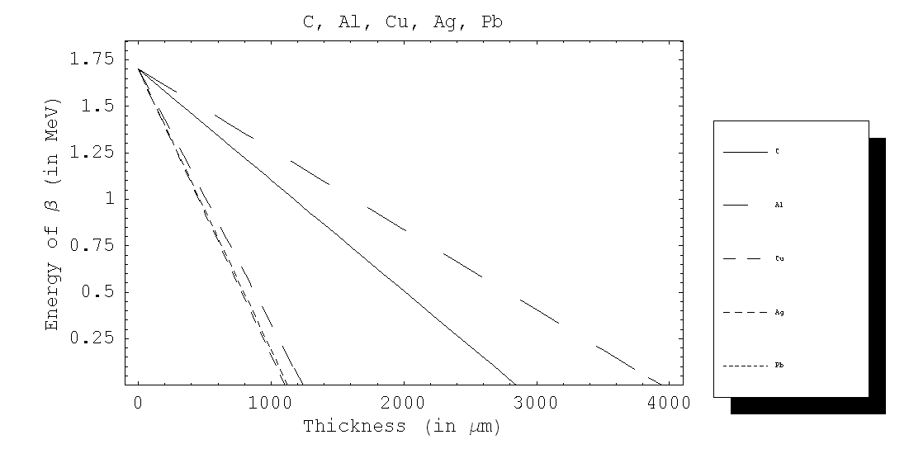
Figure 4

Final Conclusions/ Suggestions
In this experiment we attempted to use a Wilson cloud chamber to qualitatively investigate the behavior of energetic submicroscopic charged particles (namely α and β particles). We were successful in using the cloud chamber to observe the path of α particles in a gas. However, we were unable to curve the paths of these α particles by introducing a magnetic field. Since the radius of curvature of the particle is governed by the equation $r=\frac{\text{mv}}{\text{qB}}$, we could achieve a smaller radius by using lower energy particles or having a stronger magnetic field. We tried to achieve lower energy particles by making the particles penetrate a thin film (Saran Wrap, specifically). This attempt was unsuccessful though we do believe that a method similar to this could be used to achieve visible curvature in a magnetic field, perhaps by exploring other types of thin films.

We also attempted to detect β particles in our cloud chamber, but to no avail. We aren’t certain why we failed to detect the β particles, but we suggest the chamber be completely cleared of dust to eliminate the cloud that may be obscuring any activity caused by the β particles. Our hypothesis for why we failed to observe ion trails formed by the β particles is that the particles do not ionize enough of the gas molecules to form a visible trail. Two points in support of this hypothesis are that the β particles have a momentum ~118 times smaller than that of the α particles, and also that the cross section for β particles is much smaller than it is for α particles. To overcome these problems, we suggest pressurizing the chamber with a gas (Nitrogen, for example), so that the β particles will ionize more gas molecules, perhaps forming a visible trail.

